New Brighton Cricket Club

Established

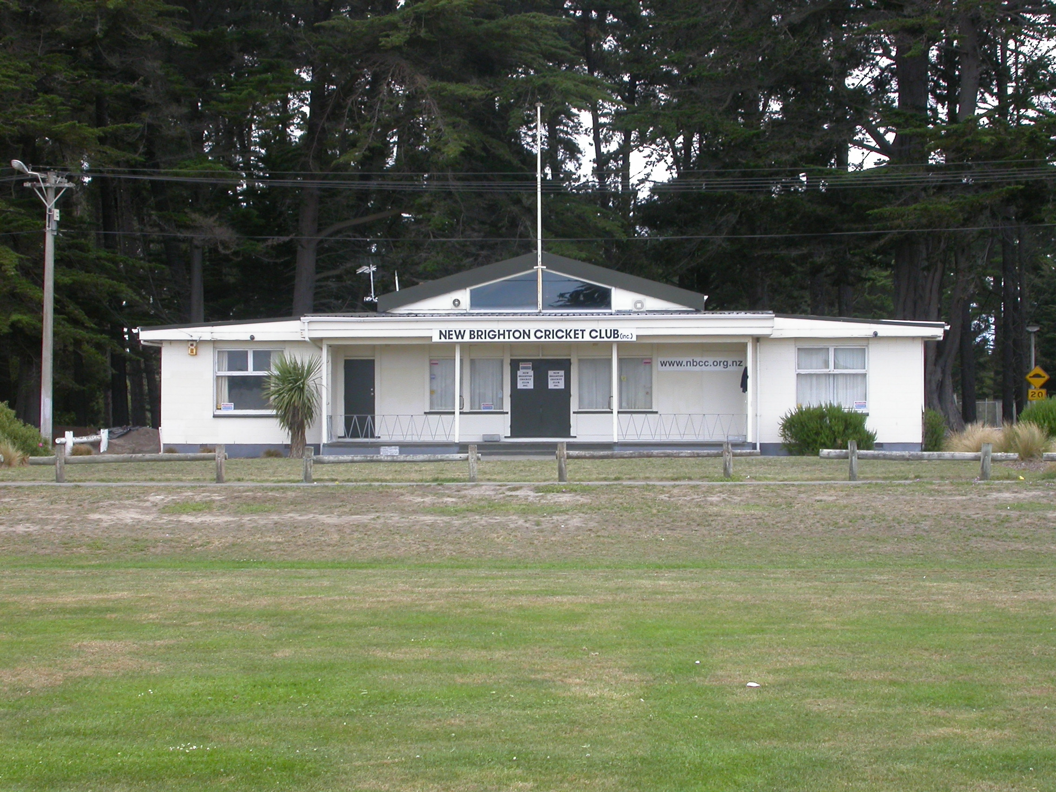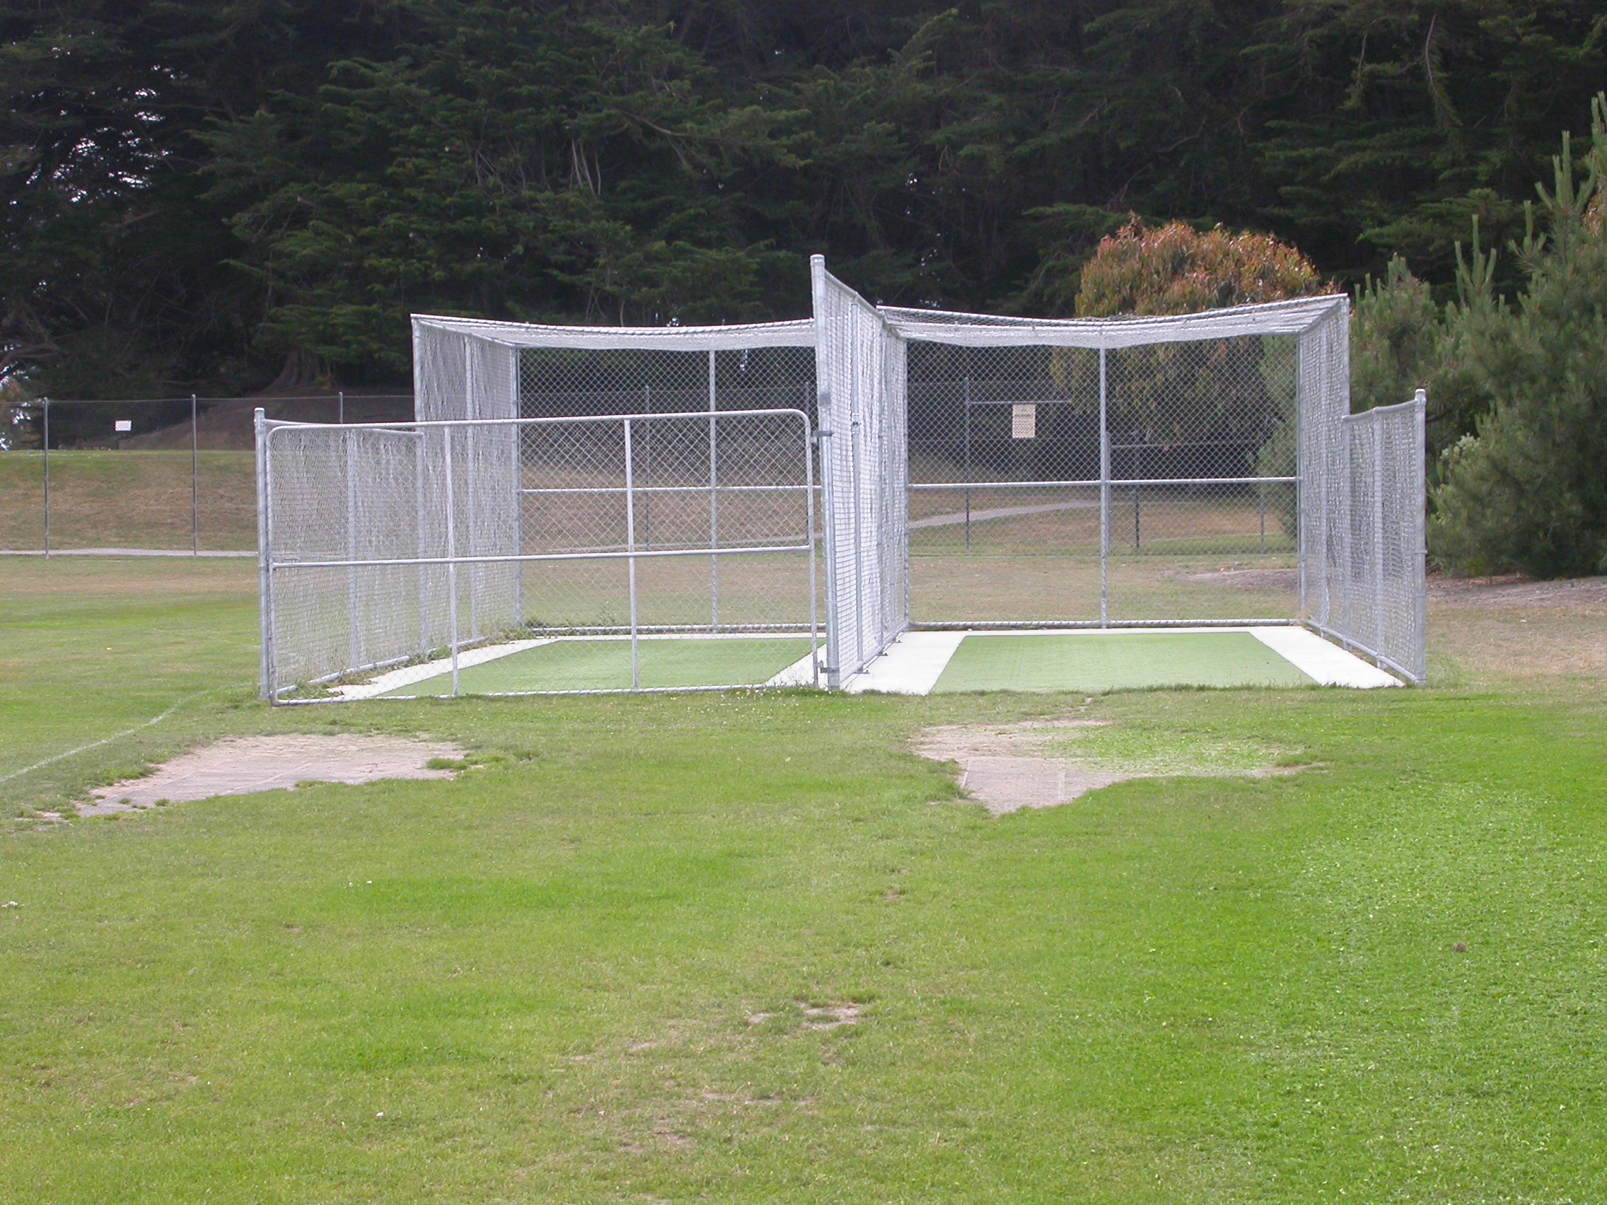

Home Ground Rawhiti Domain
Match pitches 3 grass match pitches
Practice pitches 2 artificial pitches

Entries 2001-02 5 men teams 1 women team 10 junior teams
2002-03 5 men teams 11 junior teams
2003-04 5 men teams 8 junior teams
2004-05 7 men teams 9 junior teams
2005/06 6 men teams 7 junior teams

Grade wins last 5 years 2002-03 Senior A
2003-04 Fourth C
2004-05 Senior

